暨南大学本科实验报告专用纸

课程名称 数值计算实验 成绩评定
实验项目名称 Computing Problems 指导教师 Liangda Fang
实验项目编号 02 实验项目类型 验证型 实验地点 N116
学生姓名 蒋云翔 学号 2022102330
学院 信息科学技术学院 系 计算机系 专业 CST
实验时间2024年 10 月 18 日上午10:30～ 12:10

Ⅰ、Problem
Let A be the 1000 × 1000 matrix with entries A(i, i) = i, A(i, i + 1) = A(i+1,i) = 1/2,A(i,
i+2) = A(i+2, i) = 1/2 for all i that fit with in the matrix.
• Solve the system with Ax = [1, 1, · · · , 1]⊤ by the following methods in 15 steps:
1. The Jacobi Method;
2. The Gauss-Seidel Method;
3. SOR with ω = 1.1;
4. The Conjugate Gradient Method;
5. The Conjugate Gradient Method with Jacobi preconditioner.
• Report the errors of every step for each method

Ⅱ、Algorithm summary
what is the Jacobi method? First of all, it is similar to the fixed point iterative method mentioned in the first chapter, we need to rewrite the original linear equations and iteratively solve by the initial solution system x0. The rewriting steps are as follows：
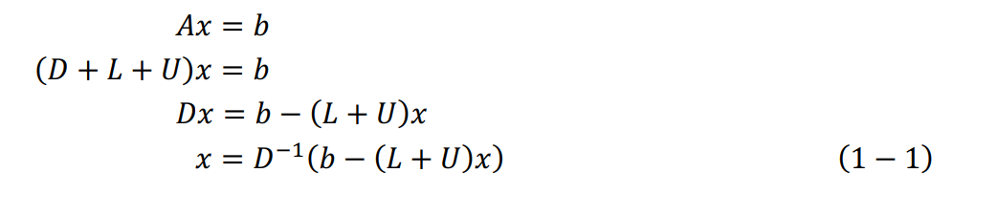
It can be observed that we decompose the original matrix A into three independent matrices: 1. principal diagonal matrix D 2. lower triangular (elements below principal diagonal) matrix L 3. upper triangular (elements above principal diagonal) matrix U And now, we can solve it iteratively as follows: 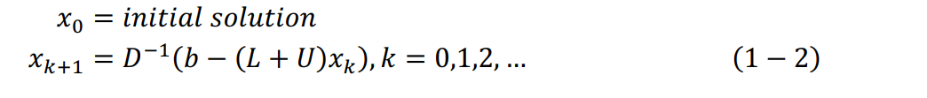

Ⅲ、Experimental procedures

Ⅳ、Result analysis

Ⅴ、Experimental summary

Appendix : Source code

